**Octave User Manual**

Octave version of FunctionPlotter

Cachary Tolentino

CSCI-3327

**Table of Contents**

**Software Description3**

Detailed Description3.1

System Requirements3.2

**Installation Guide4**

**Scripts Overview5**

**Result Analysis7**

**Software Description**

Octave version of FunctionPlotter.

**Detailed Description**

The program performs the same tasks as the FunctionPlotter program. It allows the user to output three separate csv files: an original data set of quadratic values, a salted version, and a smoothened version.

**System Requirements**

**System Requirements**

* A working device, primarily a desktop or laptop
* GNU Octave

**Installation Guide**

To begin using the Octave scripts, simply download the following files.

After downloading the files, simply move the files to the folder containing your project. Once done, you can open GNU Octave. Then change the directory to the folder containing all the files you have downloaded. Finally, you can start using the scripts, especially the “tester.m” script which will run the entire program.

**Scripts Overview**

**tester.m**

The tester.m script simply calls all the other scripts (plotter, salter, and smoother) to produce the original set of data of quadratic values, then its salted output, as well as its smoothened output. It does not require any parameters, nor does it return any result. It works as a tester script for the other scripts.

**plotter.m**

The plotter.m script handles the execution of creating the csv file containing the original data of quadratic values. It asks the user for inputs regarding the variable values for the quadratic function and the name of the file. It will then input all the quadratic values into a data structure. Finally, it will call for the exporter to export the data into a csv file and the grapher to graph the data and save it as an image. It does not have any parameters, but it does return the name of the file it created.

**quadraticFunction.m**

The quadraticFunction.m script is a helper function for the plotter.m script. It simply returns the quadratic value based on the given variables of the quadratic function. It requires four parameters: x, a, b, and c. It will return y as a result.

**salter.m**

The salter.m script follows the same procedures as the plotter.m script, but it does not ask the user for any input. The script asks the user for the salting ranges (lower bound and upper bound). This script requires one parameter: filename. The fileName is simply the name of the file that wants to be salted. While the bounds define the range of values that could be used for salting the data. The script also returns the name of the newly salted file.

**salterFunction.m**

The salterFunction.m script is a helper function for the salter.m script. It is tasked to salt the y-values of the provided data. This is performed by iterating through all the y-values of the data and randomly creating a salting value based on the given range. It will then randomly decide to either add onto the existing data or subtract from it. It requires three parameters: data, lowerBound, and upperBound. Data is the data containing the unsalted data values. This function will return the new data containing salt values.

**smoother.m**

The smoother.m script also follows the exact procedures of the salter.m script. Window value is a user defined value which represents how many numbers around a certain index value would be averaged. This function does not return any value.

**smootherFunction.m**

The smootherFunction.m script is the helper function for the smoother.m script. It is tasked to smoothen the y-values of the provided data. This is performed by iterating through all the y-values of the data and finding the average value given the window value. This will replace the current value of the current index. This function requires two parameters: data and windowValue. This function also returns newData which contains the smoothend values.

**exporter.m**

The export.m script simply exports the data provided into a csv file using csvwriter.

**grapher.m**

The grapher.m script simply outputs a graph of the provided data. It takes in data and fileName. It plots the values given after splitting it to their respective x and y values. Once plotted, it will also save the graph as a PNG file.

**Result Analysis**

The following experiment is very similar to an experiment performed with the original PSS program. We want to see the type of difference each program would create based on their unique implementation. As we can see the outputs follow the same outputs to some degree, only differing in the actual salting result due to the random nature of the salter. This directly affects the smoothing of the salted data due to the different values created.

The following graphs are example outputs of the program using Octave’s built in plot function. The quadratic output was configured with its quadratic formula as $10x^{2}-5x+50$.

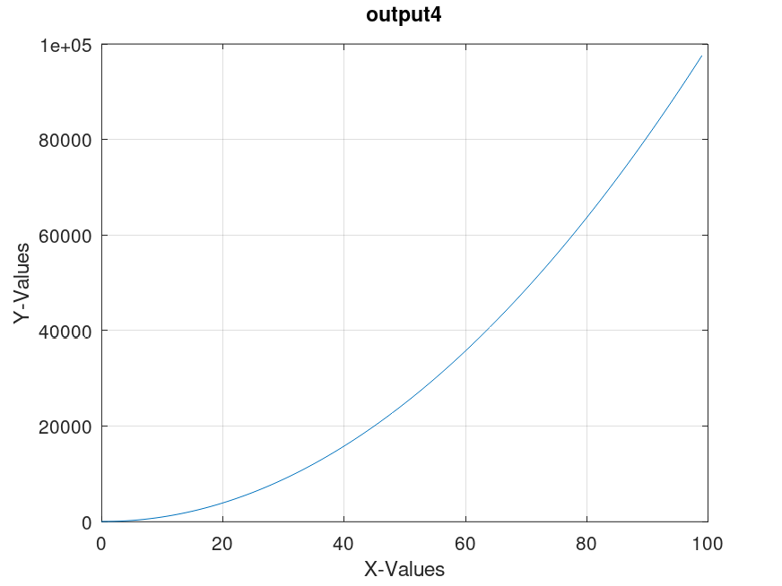

In the following graphs, we can see a more interesting difference mainly due to the salting and smoothing of the graph above.

In the graph below, we can see the salted version of the quadratic output. Here the salting range used was from 10000 to 50000. This causes the data points to either be increased or decreased from their original value, hence, the points starting to deviate from the straight line in comparison to the original graph. This graph shows a connected line output due to the plot function of Octave. The results also differ in comparison to what the original PSS program resulted with.

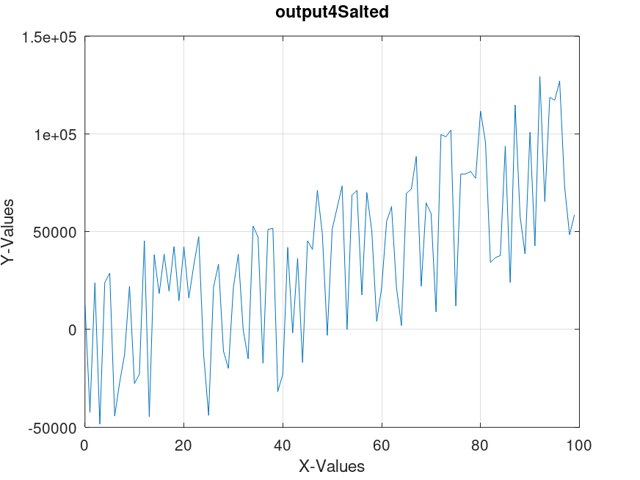

Finally, here we can see the smoothened graph of the salted graph. This used a window value of 20, as such any points on the graph were replaced with the average value of the values from that focus point’s left and right side. This “smoothens” the salted values thus allowing the graph to appear more like the unsalted version.

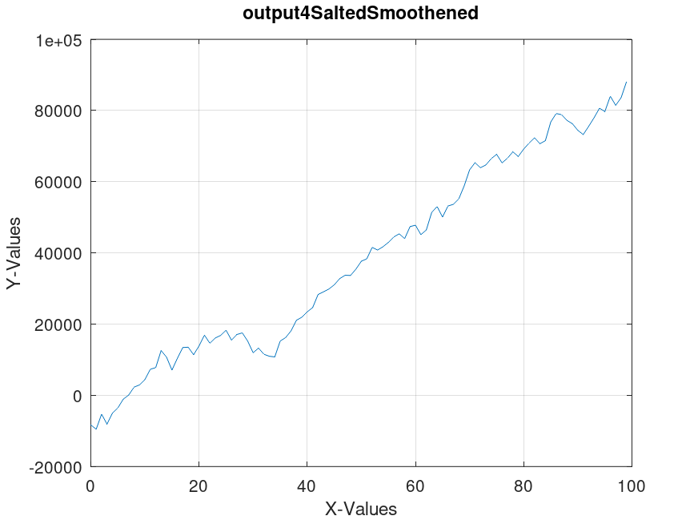

The result starts to resemble the original graph before the salting. This shows that the smoother function works properly. To further improve this result, we can iterate the smoothing function multiple times.